**MEMORANDUM**

**From: Minwoo Cho**

**To: Professor Deborah Sills**

**Date: September 17, 2013**

**Subject: Lab 3: Part II**

Objective of this lab was to determine the parameters for the sorption isotherm of chlordane on granulated activated carbon (GAC). The laboratory study was done and data was collected prior to this computer lab. The data from the laboratory experiment will be used in Kaleida graph to fit one of two sorption isotherms – linear and Freundlich. Equations for both linear and Freundlich is included in the Appendix.

Both linear and Freundlich sorption isotherms were plotted in Kaleida graph along with the data to see which method fits better. Equations 1 and 2 in appendix was used to graph linear and Freundlich isotherms. A plot of linear isotherm is attached in the appendix as figure 2, while plot of Freundlich isotherm is attached below.

After plotting both linear and Freundlich sorption isotherm, it was clear that Freundlich sorption isotherm fits data better than the linear sorption isotherm. K, reaction rate for the Freundlich was lower than of linear method’s. Freundlich method fitted the data better visually as well.



Figure 1: Freundlich sorption Isotherm Fitting

Appendix

$q=KC$ (1) Equation 1. Linear Sorption isotherms

$q={KC}^{\frac{1}{n}}$ (2) Equation 2. Freundlich Sorption isotherms

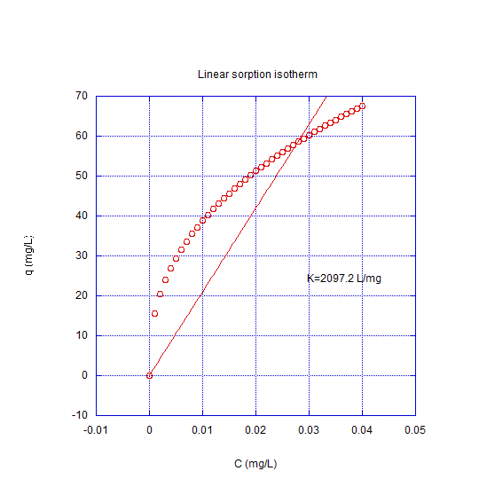

Figure 2: Linear sorption Isotherm Fitting